Hello wonderful future assignment people, I thought I’d make this to help organize my the project and ultimately help me keep track of how much work I’m putting into this and where I need to work on next.

2022-10-23 13:36
Just added a way to close the window using functions + the close button. X11 is deinately an archaic display server with wayyyy to many ways to close. Hopefully the solution I’ve found works for most users. Does for me.
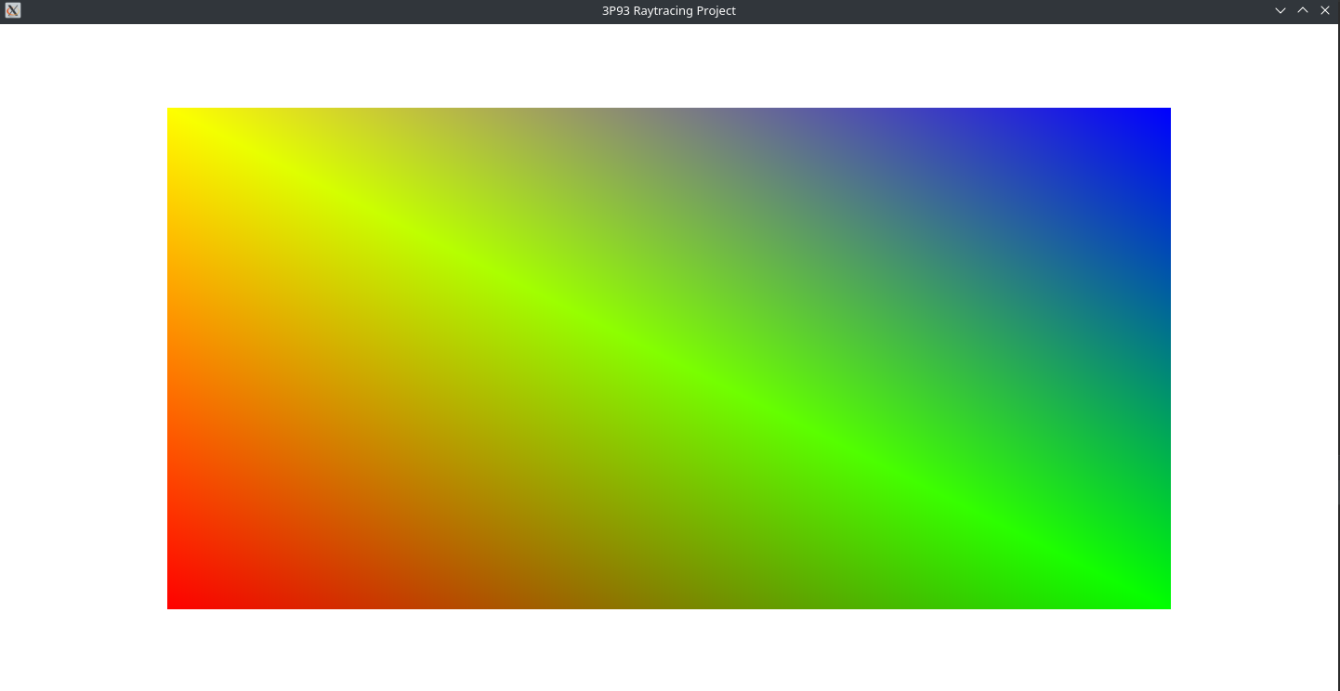
Next step is getting input working.

2022-10-23 14:07
Realized that it would be better to get at least something drawing on the screen before I try to do any input nonsense. Might be a bad idea but I need to get this done. So since the threads (single and multi) are only going to be writing to the image we can very easily just read data from the main thread without any worry. Even if the data is out of sync on the cache it’ll be up to date hopefully by the time we repaint the screen, which should be every 16.6666ms or 60 frames per second.
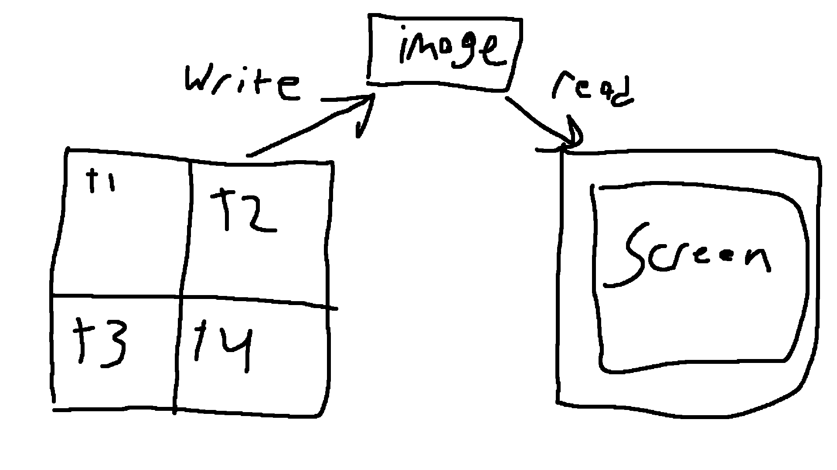

The general concept crudely drawn above.

2022-10-23 16:35
Multithreading is in although I was going to leave it for later. Currently running a debug session trying to determine where the segfault on larger images is occuring. Might have to move some stuff off the stack?

2022-10-24 17:27
Alright so I fixed multithreading so that every core is used 100% until the entire scene is finished. Did this by further splitting up the screen, adding to a queue, then each thread takes from that queue. Hardest part was trying to get the mutex to work and get the queue to not crash. Switched away from sending lambda functions and instead just send the numbered needed to do the rendering. However the queue did need to be made a heap object and not passed via reference. No clue why the reference to a stack object was giving such troubble but hey it works now and according to the profiler all threads are used about equally. Only takes about 20,955ms to render the same image that took 3.5 minutes on single threaded! Currently there is an issue with the renderer where the righr edge is a black bar and so I am going to go fix that instead of studdying for my midterms this week :/

Yes I was mulling over this all day today and yesterday :(

2022-10-24 17:32
Okay turns out this:
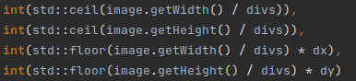

Was a really bad idea.
This fixes all black bar issues:
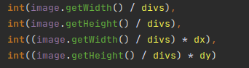

Let’s see if I can get some basic GPU stuff by the end of tonight.

2022-10-24 22:28
So I fixed the issues with really weird segfaults where the engine was writing to image pixels outside the with and height
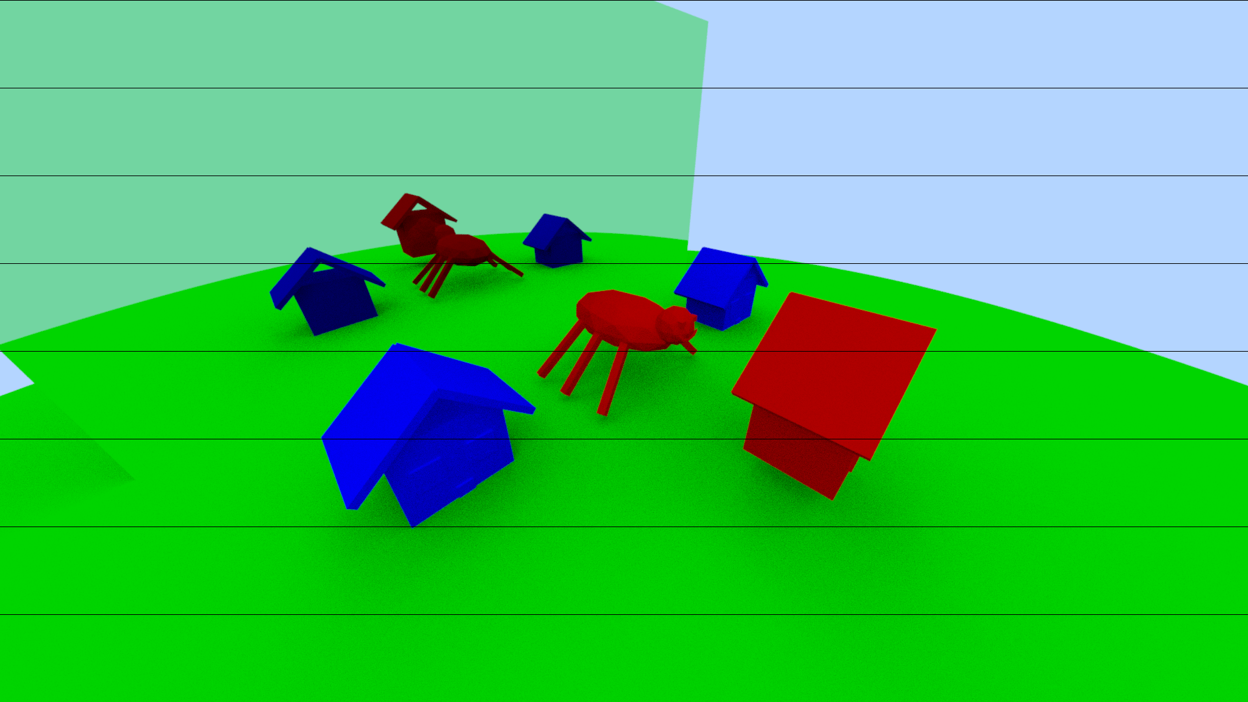
Except it causes this really weird issue which doesn’t make sense
So I think im just going to double the memory allocation or something. It’s small compared to whatever.

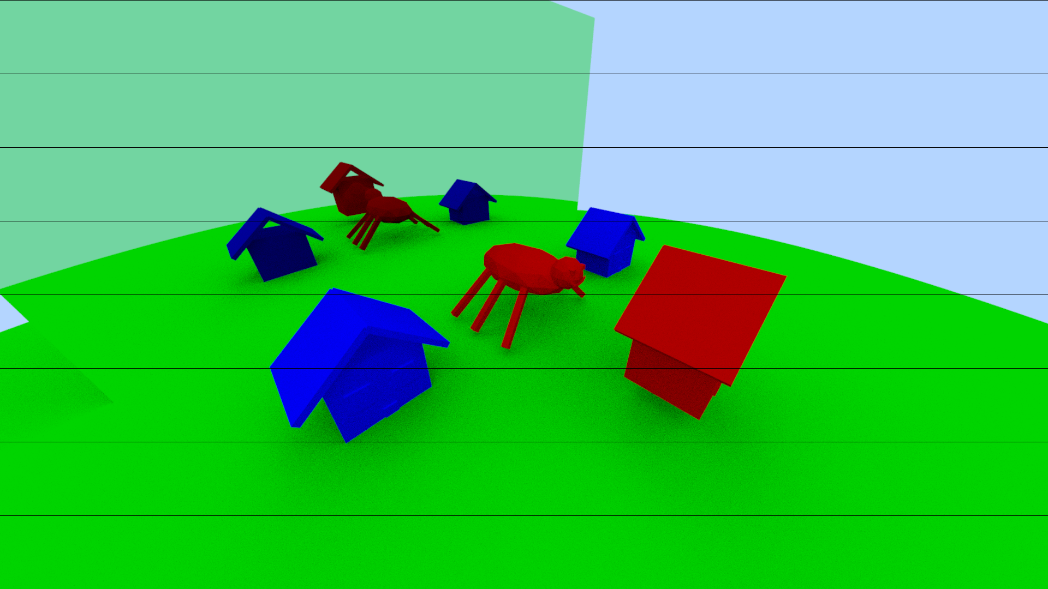
Didn’t fix much. Wonder what’s going on. Zooming in I can see it looks to be a floor issue rather than a ceiling issue. Might be realted to the offset causing the memory issues?

2022-10-25 00:09
Fixed the lines issue. No clue how. Well i think i changed a double to an int and now it works except that some resolutions have weird lines (1920x1080, default settings)
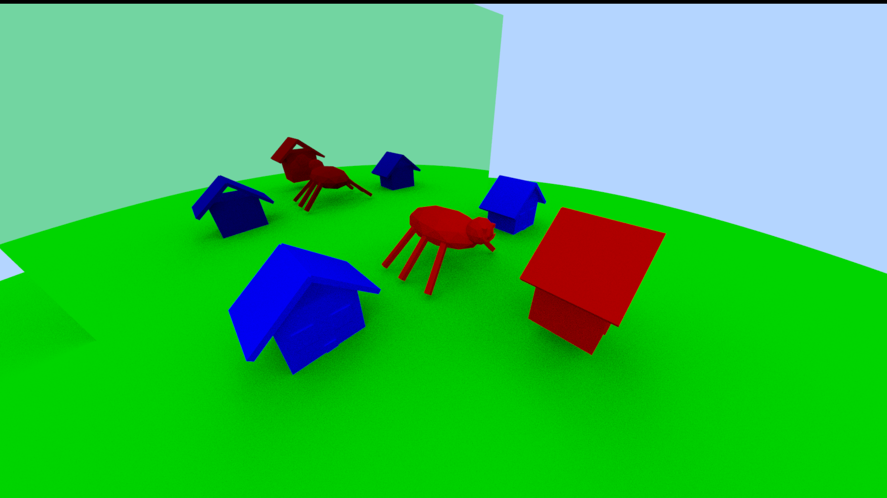
while others dont (2048x1024, 1440x720)
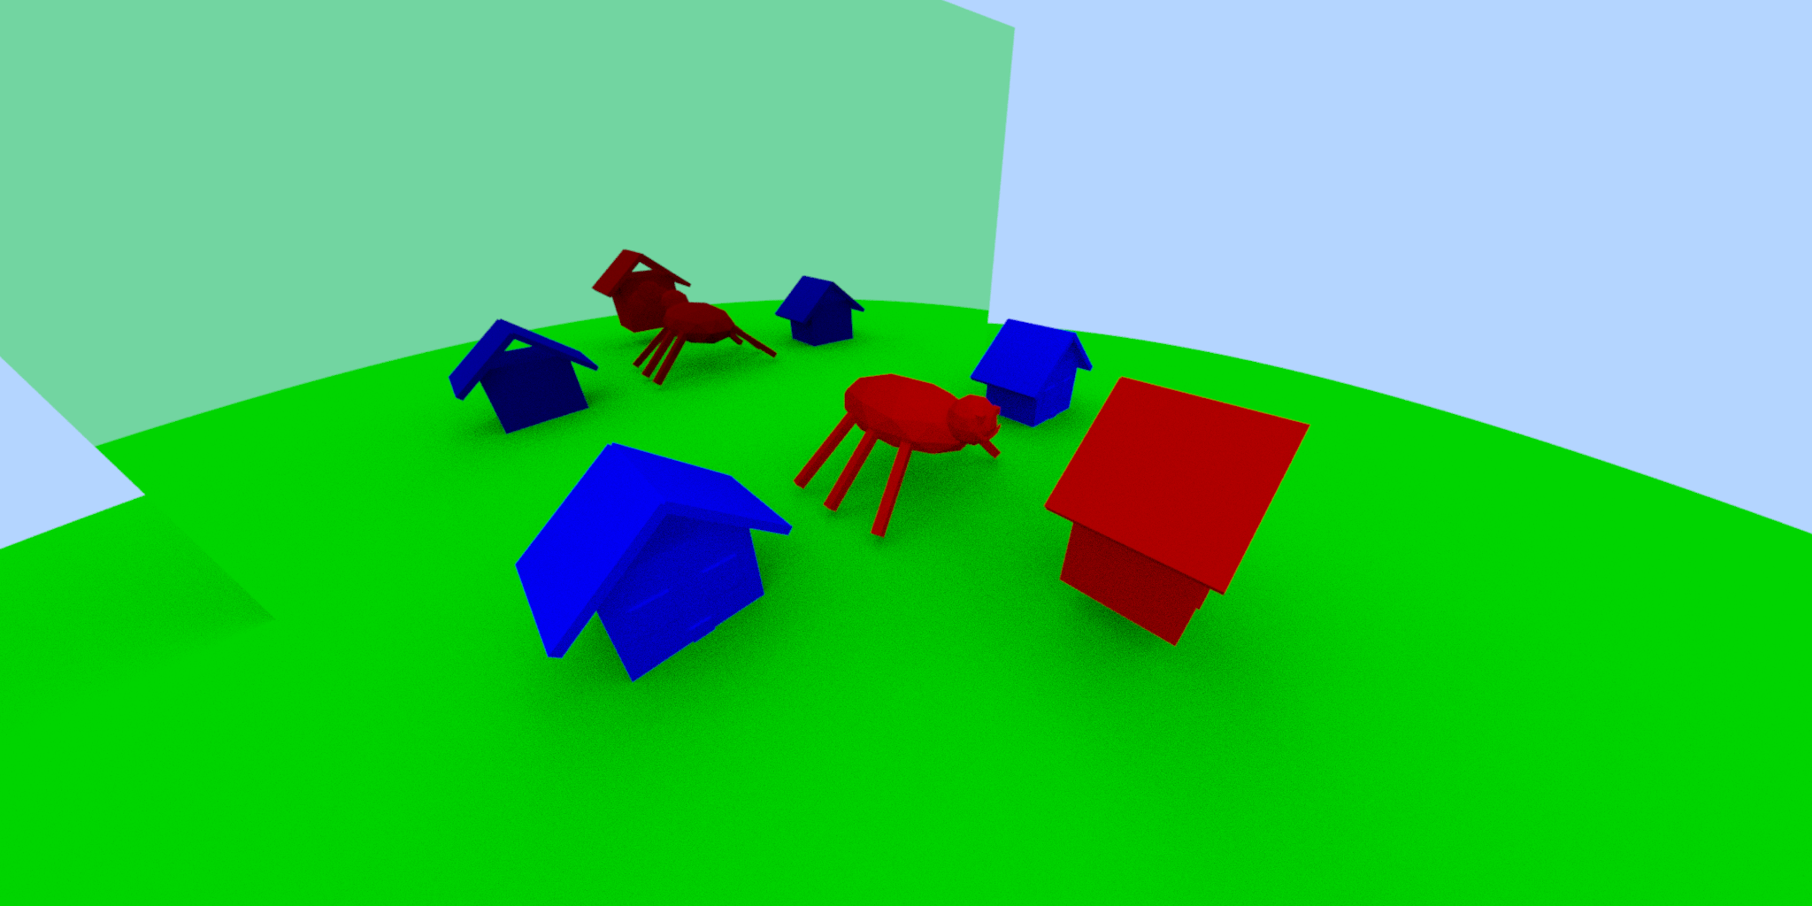
2022-10-25 01:04
Profiler says iterative version of the raycast function is 4.5% faster but im not sure if it’s accurate considering I’m taking a few shortcuts. Image looks fine though.

2022-10-25 12:25
I’ve made some changes to the iterative renderer
this is what it was producing:
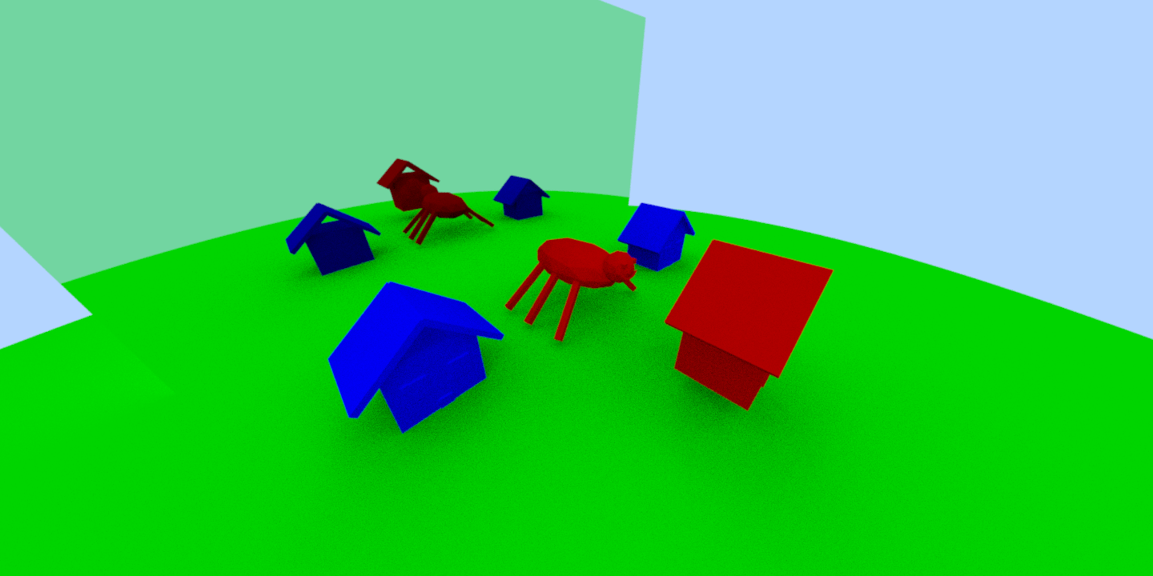
vs what the recursive was producing
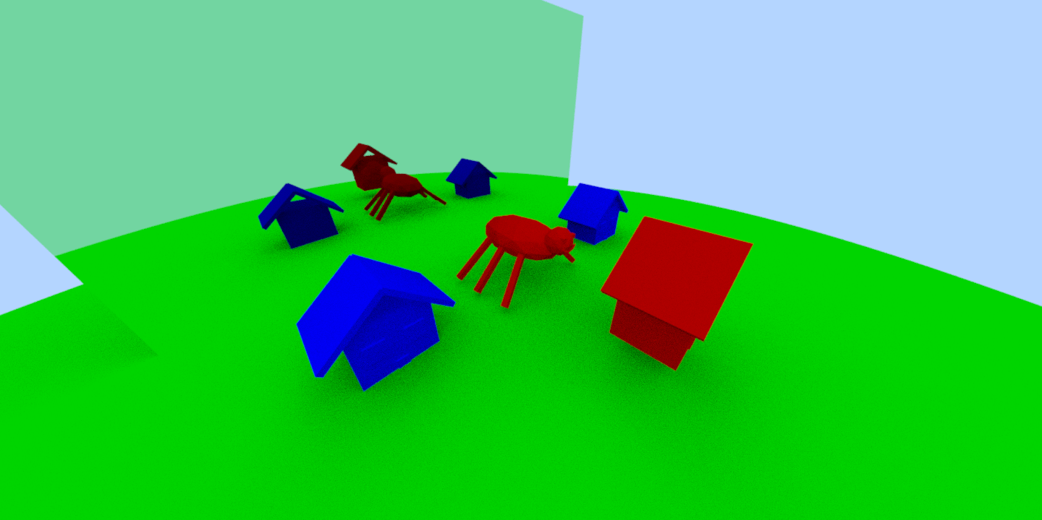
We can see that there is some shadowing missing.
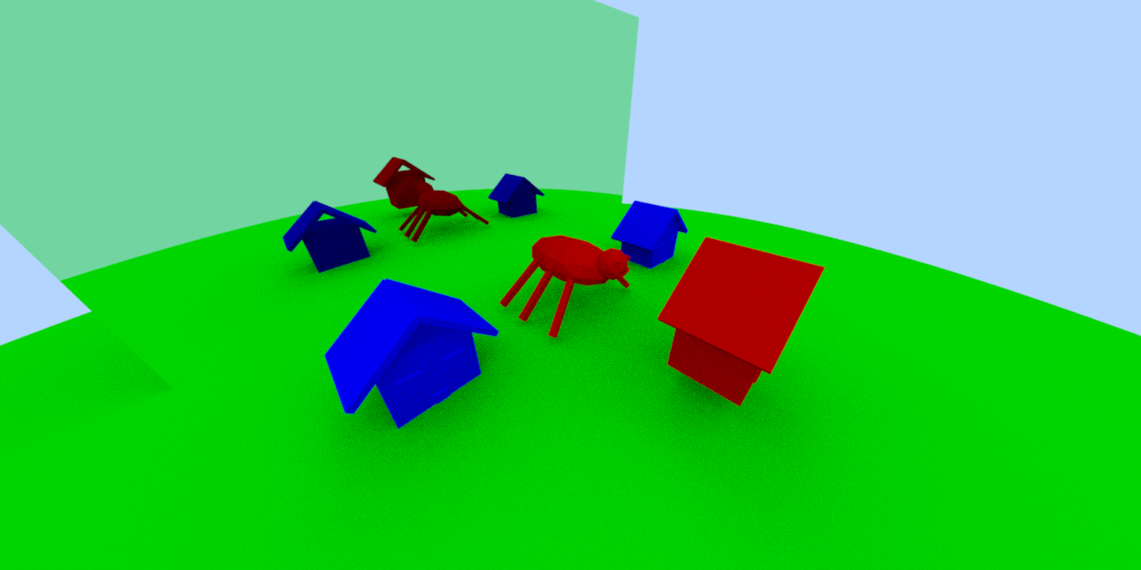
The new results keep the shadowing of the recursive ray tracer. The old iterative was using a while loop with a queue but it turns out since the recursive function is only called once per possible ray you can just use a for loop that exits early if the ray doesn’t bounce / scatter. Works much better this way. The new version runs 3.7% faster.

Found this wonderful PDF by AMD
https://indico.wigner.hu/event/189/contributions/61/attachments/129/404/AMD_raytracing_best_practices.pdf

Good tips on it for when I do GPU stuff.

2022-10-25 17:17
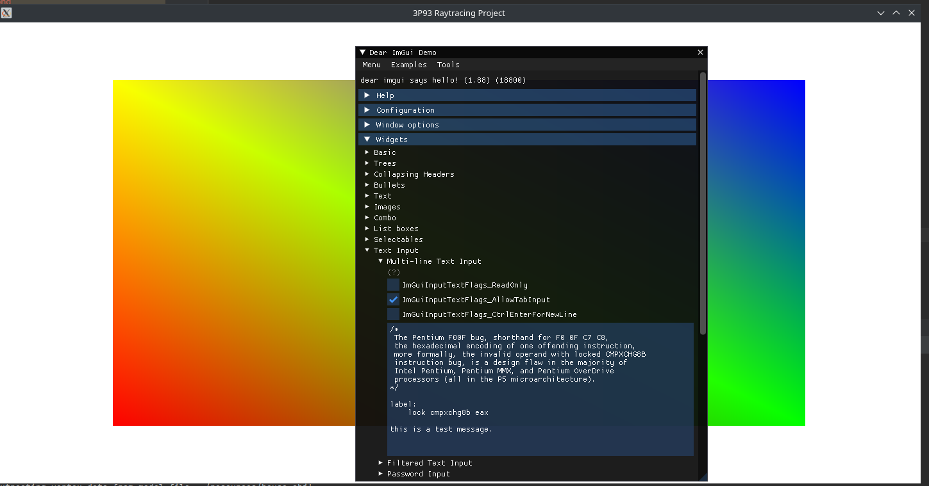
Finally got the GLFW backend to work with raw X11. Makes me wish I used glfw. ImGui of course now works that the GLFW backend is adapted to work with X11 (basically a whole rewrite). Standard OpenGL3 loader though. Since it uses its own bindings it was really simple to setup. Colored rectangle in the background has been there for a while. Time to add image output.

2022-10-27 17:20
Finished my exams for the week, after neglecting them due to this project. I’ve added a VAO class for loading VAOs to the GPU. Not sure if it works but hopefully it does. Working on texture class next then will have to make an FBO class.

2022-10-28 1:20
I’ve gotten a quad to render with vairable color again, this time just read. Applying the image which should be being update isn’t working. Renderdoc is having issues with raw X11 windows apparently. Not completely sure why yet, might have to switch to glfw and glad. It’s one thing to do things on your own but it’s another to try and debug opengl applications without renderdoc. Oh yeah debug mode is also now stupidly laggy and crashes if you click anything in imgui. Release mode doesn’t. Another reasont to use proper libs.
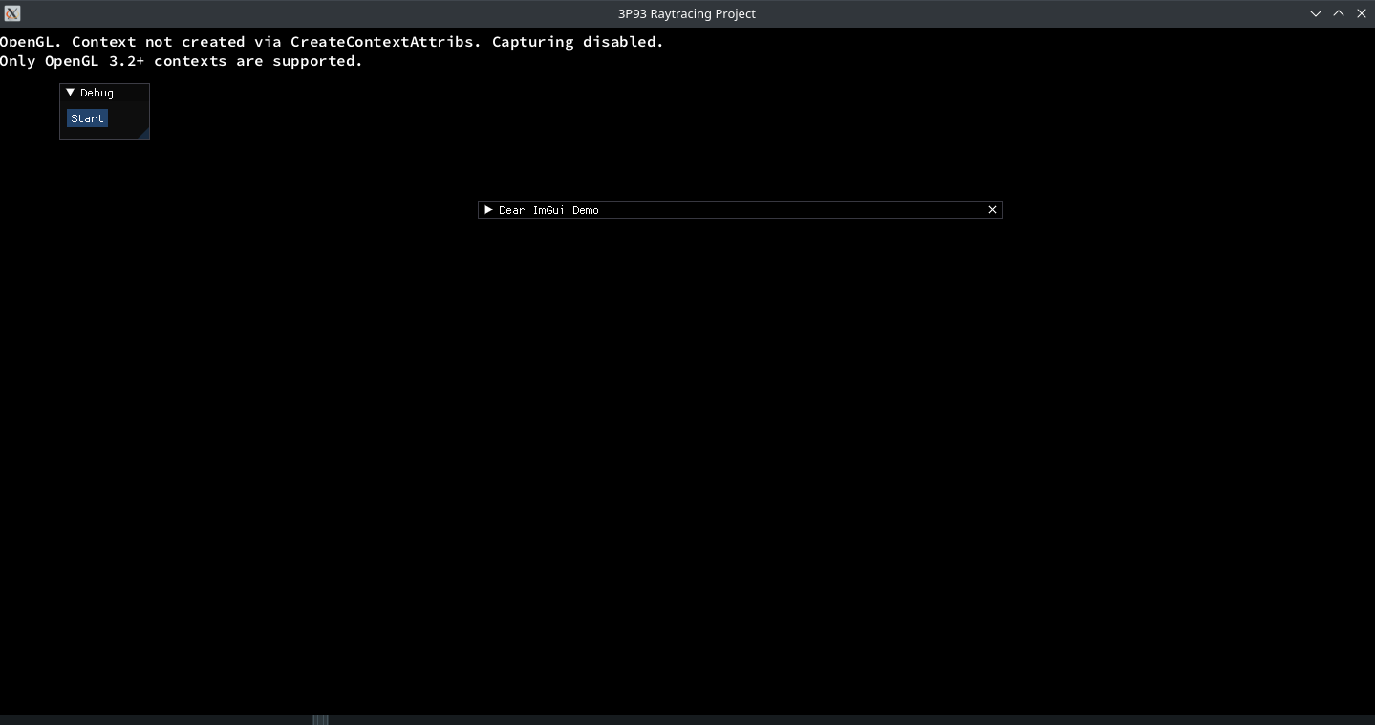
Actually got it to work in renderdoc.... but:
:/

Turns out I have extra steps to do. Why was it letting me use GL3.3 functions if it was old gl setup only??
2022-10-28 12:47
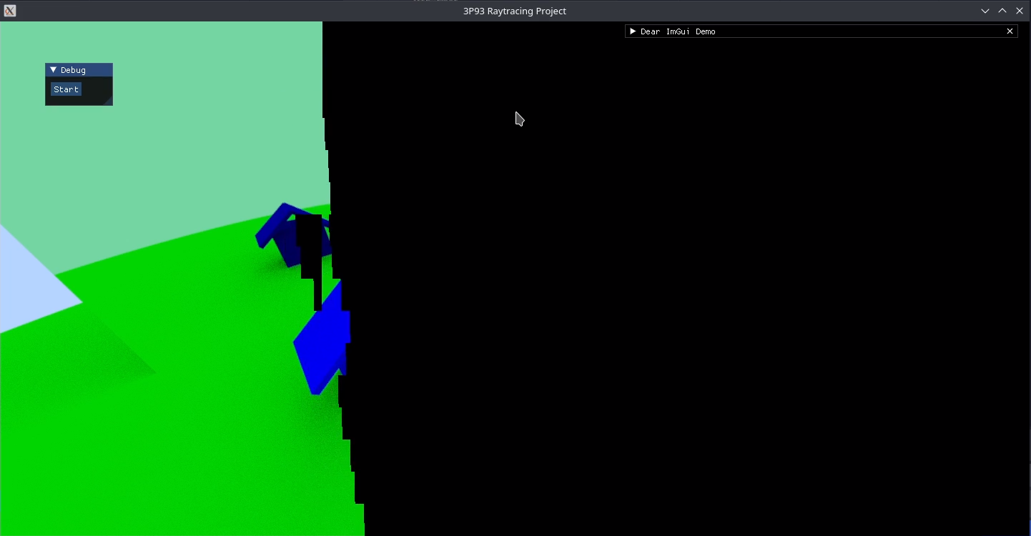
It works!!!!!!!! I finally got the GL4.5 context working! Also set the new context to be core profile only so renderdoc works great! Helped me figure out that the isssue was the glTextStorage2D requires you to specify the bit depth for the internal format. Required GL_RGB8 instead of GL_RGB. Credit to past me who used 3d textures in a similar method for his minecraft clone having figured this out already.

The single threaded version looks cool too (very slow)
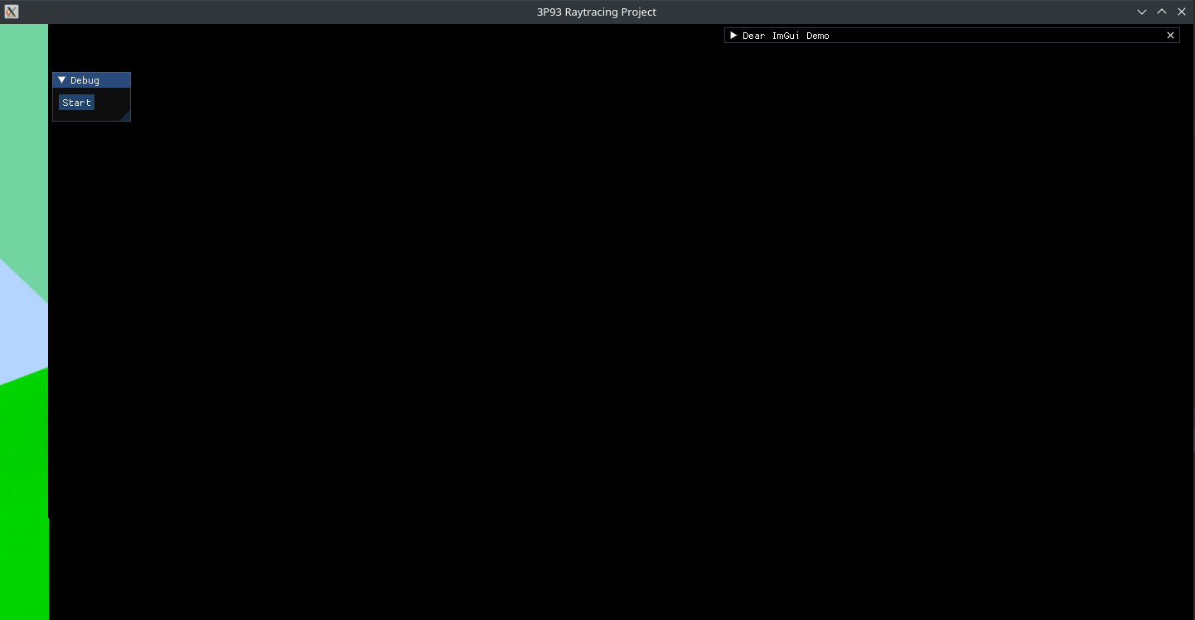

2022-10-28 14:09
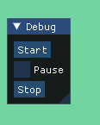
Added the ability to stop and pause the raytracing!

2022-10-28 14:59
Fixed issues relating to the new start and stop. Lots of
dumb memory issues that I’ve resolved using smart
pointers.

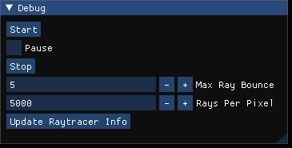
Added ability to chance raycaster values as well.

